**Question bank**

Subject :Data Structures

1. Which are different traversal methods? What are applications of it?
2. Explain B-tree and B+ tree with example.
3. Show precedence of evaluation for the following operators in case of evaluation of infix operation  
   +, -, *, / and exponentiation
4. Write a program for merge sort method.
5. Sort the given numbers with quicksort algorithm.  
   34, 2, 56, 45, 7, 12, 33, 9
6. Search the number 55 from the given list with binary search method  
   20, 2, 34, 55, 60, 43, 12
7. Compare different sorting methods based on its complexity.
8. Which asymptotic notations are used for analysis of algorithm? What is time complexity of merge sort, quick sort and heap sort algorithms?
9. Find minimum spanning tree with Kruskal’s algorithm for the following graph.

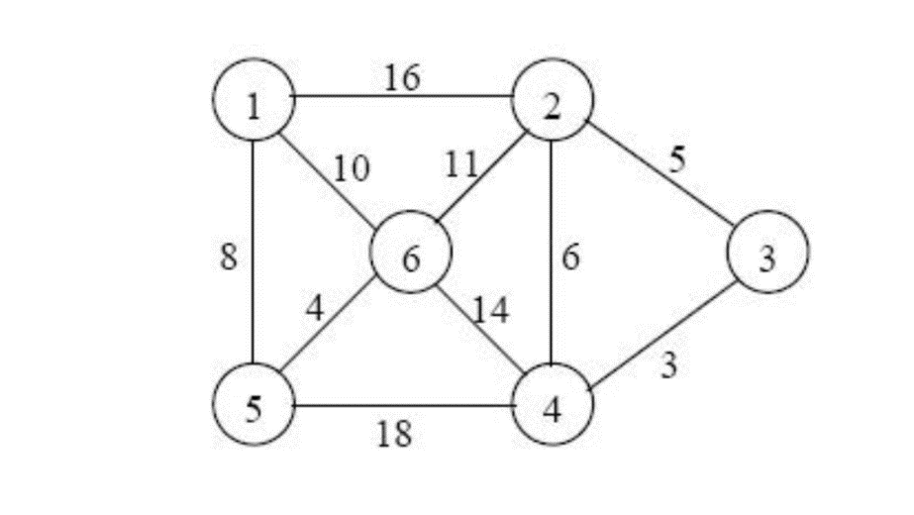

1. Define spanning tree. Write an algorithm to find minimum cost spanning tree with Kruskal’s algorithm.
2. Sort the following list of numbers with heap sort, quick sort and radix sort method.  
   23, 44, 3, 20, 15, 10, 45, 50, 7
3. Write an algorithm for heap sort.
4. Write an algorithm for bubble sort method.
5. Explain reference count method of automatic list management.
6. Which methods are used for automatic list management? Describe.
7. What is garbage collection method? Explain in brief.
8. How to do dynamic memory management with first fit, best fit and worst fit method.
9. Apply first fit method for memory allocation for jobs given in the table.

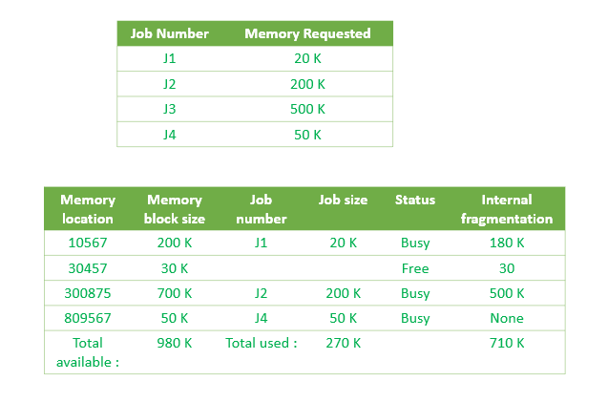

1. Apply worst fit method to allocate memory for the following example.

Input : blockSize[] = {100, 500, 200, 300, 600};

processSize[] = {212, 417, 112, 426};

1. Explain Boundary tag method and buddy system.
2. Define queue and priority queue, header nodes.
3. Write a function to insert and remove nodes from a list.
4. Write getnode and freenode operations and apply it insert and remove a node by writing it’s functions.
5. Describe circular list and doubly linked list with diagram.
6. Add an element to the front of a list showing diagram and write steps .
7. Write remove and insert operation with linked implementation of queues.
8. Explain array implementation of lists with example.
9. What are the advantages and disadvantages of representing a group of items as an array versus a linear linked list.
10. Write an algorithm to append an element to the end of the list.
11. Write an algorithm to delete the last element from the list.
12. Write an algorithm to delete the nth element from the list.
13. Write an algorithm to insert an element after the nth element of a list.
14. Implement the functions empty, push and pop using the array and dynamic storage implementation of a linked list.
15. Write an algorithm/program to push, pop and empty operations.
16. Evaluate the given expression using stack.  
    7 – ( ( X * Y ) / ( J – 3 ) ) + Y ) / ( 4 – 2.5 ))
17. Write functions for push and pop operation which checks empty condition and overflow condition.
18. Convert given infix expressions to postfix.  
      
    i) (A + B) * (C – D)  
    ii) A $ B * C – D + E / F / (G + H)
19. Convert given infix expression to prefix.  
    i) (A + B) * (C – D)  
    ii) A $ B * C – D + E / F / (G + H)
20. Write a program to evaluate to postfix expression.
21. Evaluate the following postfix expression using stack.  
    6 2 3 + - 3 8 2 / + * 2 $ 3 +